Practice Effectively

*Master Your Scales and Instrument*

R. R. Solomon

# Table of Contents

Table of Contents 2

Introduction 3

Required Knowledge 3

Order of Operations 4

Part 01: Scales (The Warm Up) 5

Exercise 1: Ascending/Descending 5

Exercise 2: Descending/Ascending 7

Interlude 9

Part 02: Scaling in Thirds 10

Exercise 01: Ascending (1-3)/Descending (3-1) 10

Practice Effectively

*Master Your Scales and Instruments*

# Introduction

So, you’ve already learned all of your scales, triads, 7th chords, and arpeggios? Well, you got to practice them. Now there are several ways to practice, but this is a complete guide on how I go about practicing my scales. Mind you, this is a really long practice routine, and could easily be broken up into a several day regiment, however you choose to break it up, this is how you would go about practicing each scale effectively.

Some word of advice, I suggest that you put away some time to go through this entire routine. It’s a pretty length one if you decide to sit down and perform the whole routine in one go.

## Required Knowledge

Here are a couple of things that you need to know before hand. If you haven’t learned everything that is on this list, that’s OK, we’re going to go through these things in this book, however, this book will teach you how to practice them efficiently. If you want a reference to any of the follow concepts, you can check out The Scale Bible: The Last Book You’ll Ever Need.

* Circle of Fifths
* Scales
* Diatonic Triads
* Diatonic 7th Chords

## Order of Operations

Before we begin we must first ask ourselves what order do we practice our scales in. To do this we will use the circle of fifths. What I like to do is pick a random point on the circle of fifths and then move up clock, or counter-clock, wise to determine the next scale that we will use, and we will do this until we have played through all 12 diatonic scales. So, if we were to start at **C Major/A Minor**, we can move clockwise, 4 scales up, you'll end up at **E Major/C # Minor**.

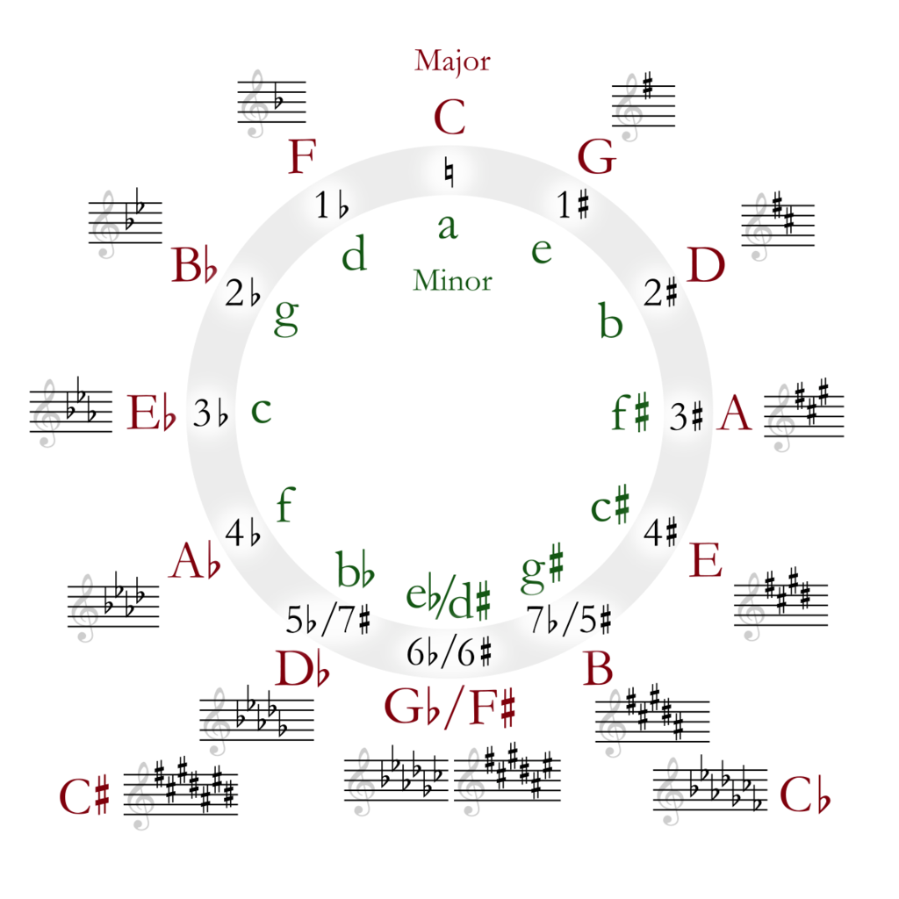

Now, the reason that we are doing this is because it keeps the scales from being boring and keeps us from making mistakes, because if we played **C Major/A Minor**, and then immediately played **G Major/E Minor**, there are barely any differences between both scales, that only being the **F found in C Major**, and the **F# found in G Major**, so the positions and fingers for each position will be very similar and might cause you to make a mistake, and confuse certain positions and fingers.

Though there are several possible combinations that you can go with, I'll be starting off with the first one. You can go about practicing the rest of the combinations. Below is a chart of various ways you can go about practice this routine, however, we'll be sticking to **Skip 3** Starting on C Major/A Minor for now. For more Orders of Operation, you can always take a look at the “Practice Effectively: Orders of Operation” document that comes with this practice routine.

### Skip 3 Starting on C Major/A Minor

**Formula:** 3(n + 4), n+5

1. C Major/A Minor
2. E Major/C*#* Minor
3. A*b* Major/F Minor
4. G Major/E Minor
5. B Major (C*b* Major)/G# Minor (A*b* Minor)
6. E*b* Major/C Minor
7. D Major/B Minor
8. F#/Gb Major/E*b*/D#Minor
9. B*b* Major/G Minor
10. A Major/F# Minor
11. D*b* Major (C# Major)/B*b* Minor (A# Minor)
12. F Major/D minor

# Part 01: Scales (The Warm Up)

***Note****: This part requires you to know your scale positions in all keys. If you do not know your scale positions you can use The Scale Bible: The Last Book You’ll Ever Need as reference along side this practice routine.*

This part will begin with you playing the scale positions that you learned from *The Scale Bible: The Last Book You’ll Ever Need*. For these examples, I will go over them in **C Major/A Minor**, so you can have an idea on how to practice the rest of the scales.

## Exercise 1: Ascending/Descending

1. Position 0 (Ascending)
2. Position 1 (Descending)
3. Position 2 (Ascending)
4. Position 3 (Descending)
5. Position 4 (Ascending)
6. Position 5 (Descending)
7. Position 6 (Ascending)
8. Position 0 + 1 Octave (Descending)

### Position 0 (Ascending)

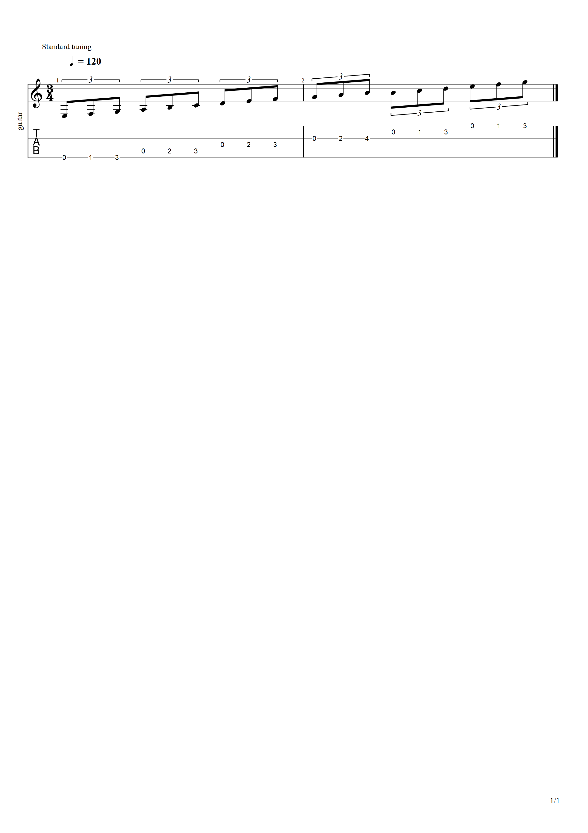

### Position 1 (Descending)

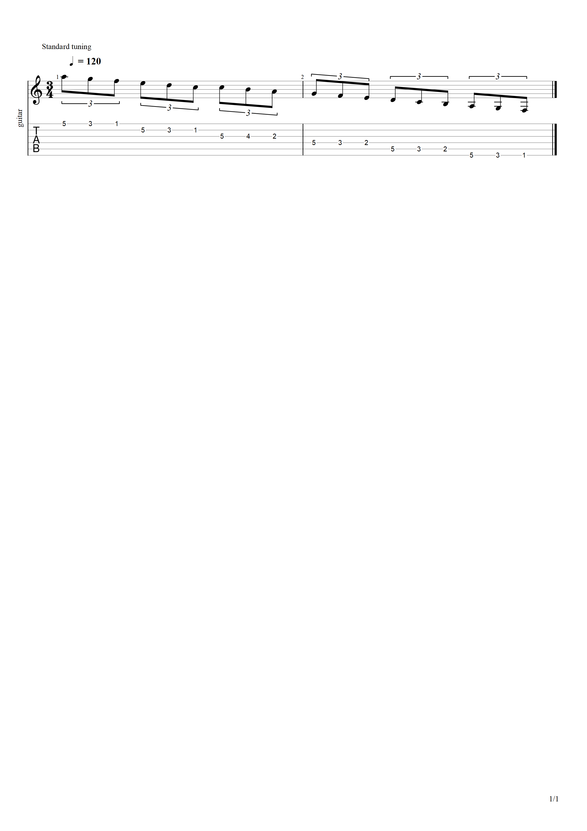

### Position 2 (Ascending)

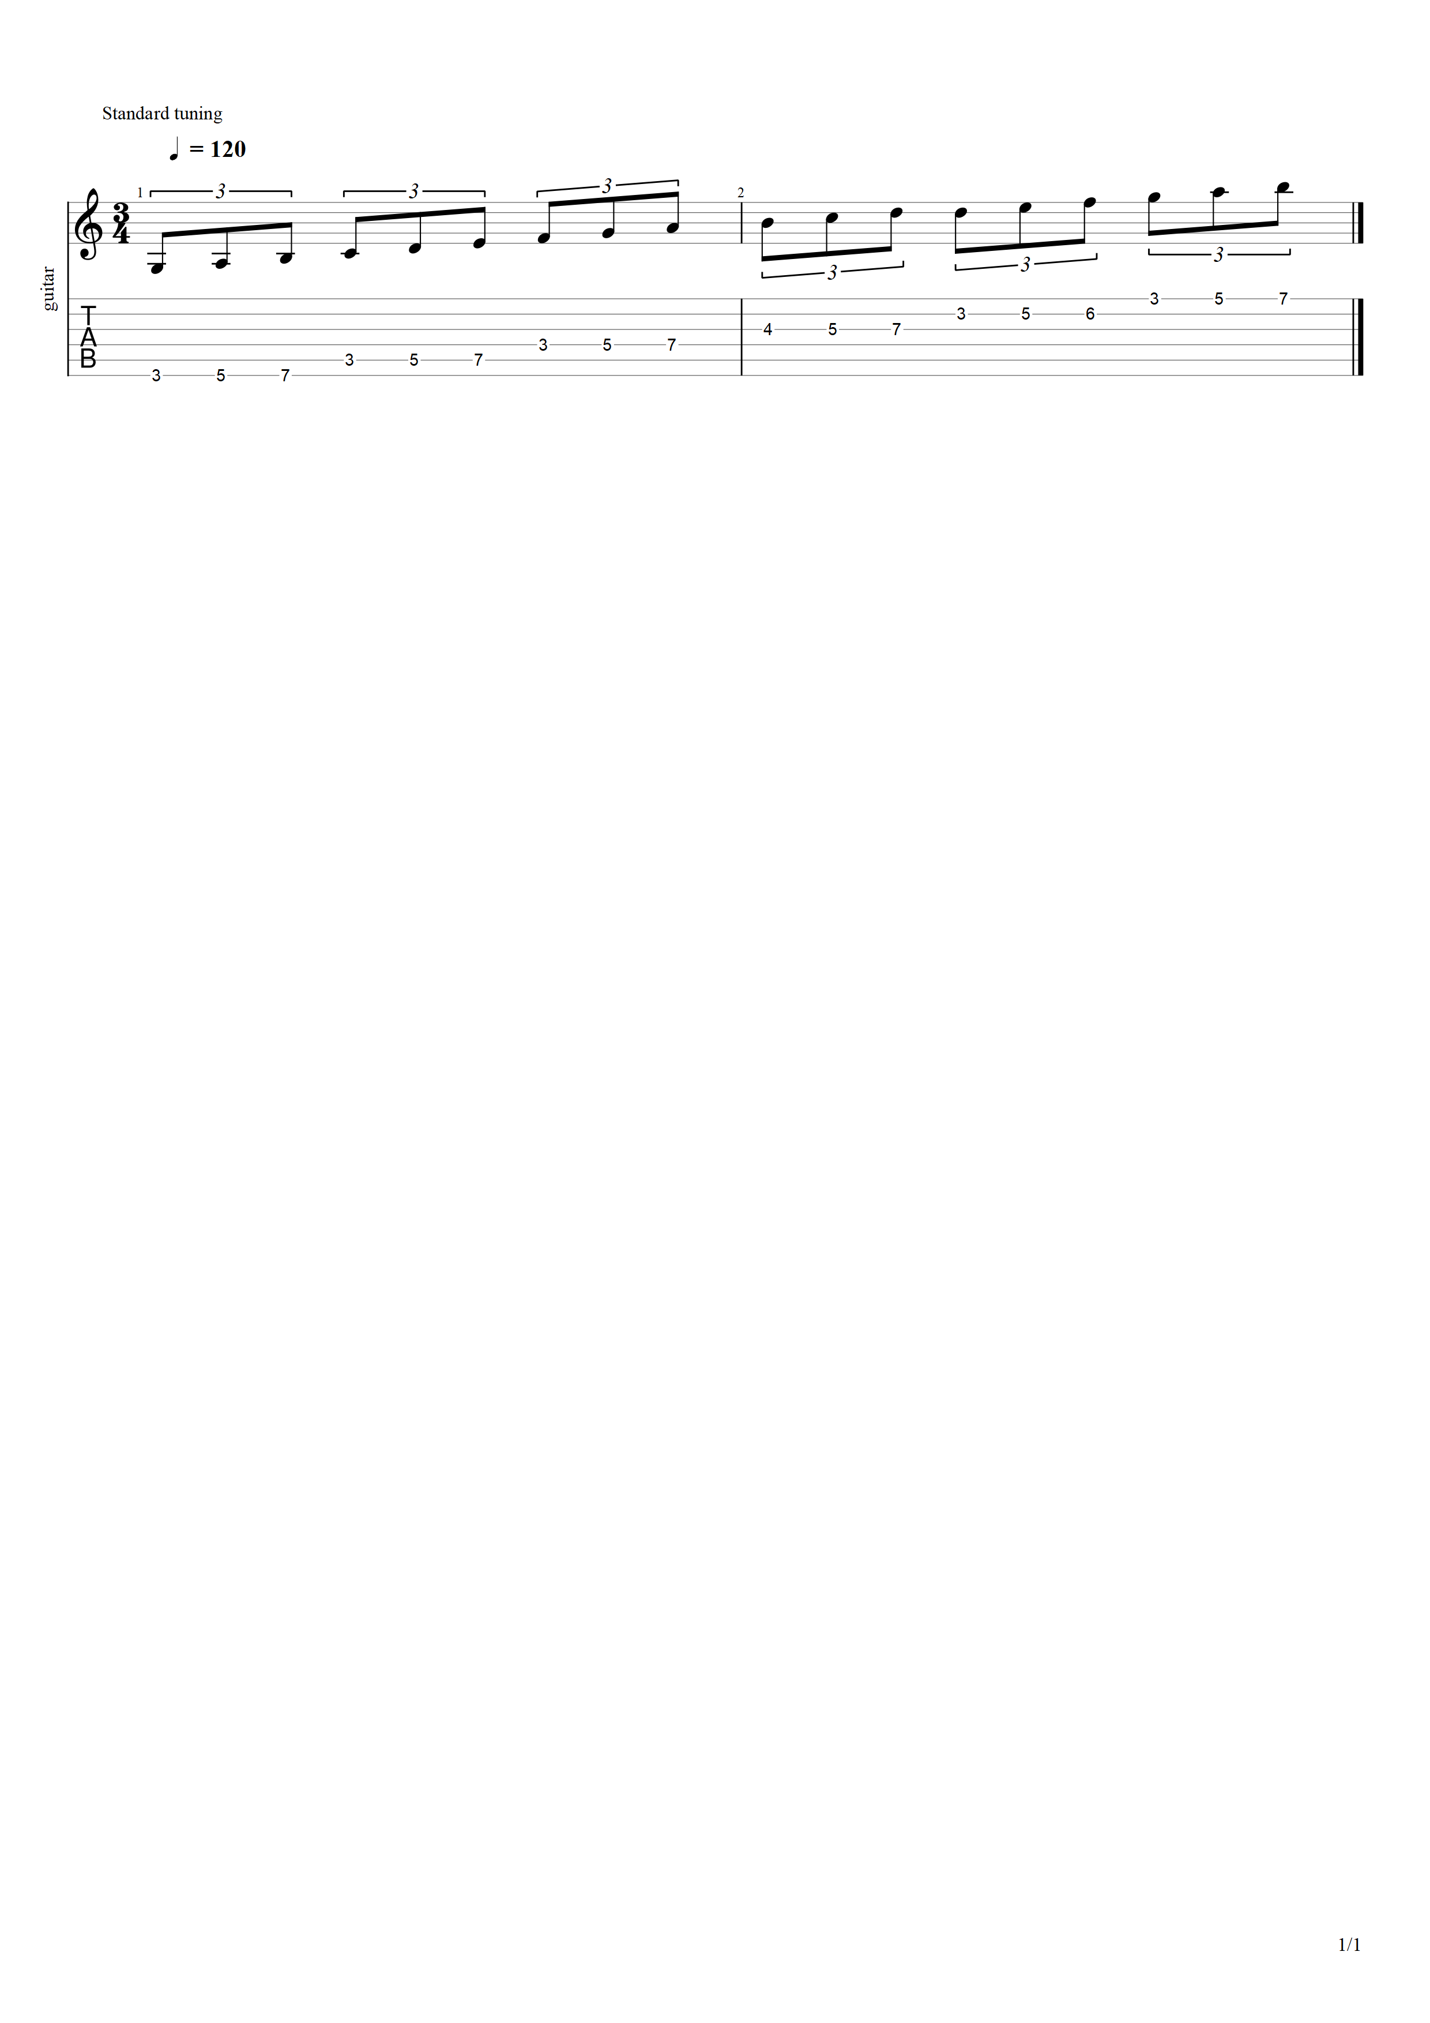

### Position 3 (Descending)

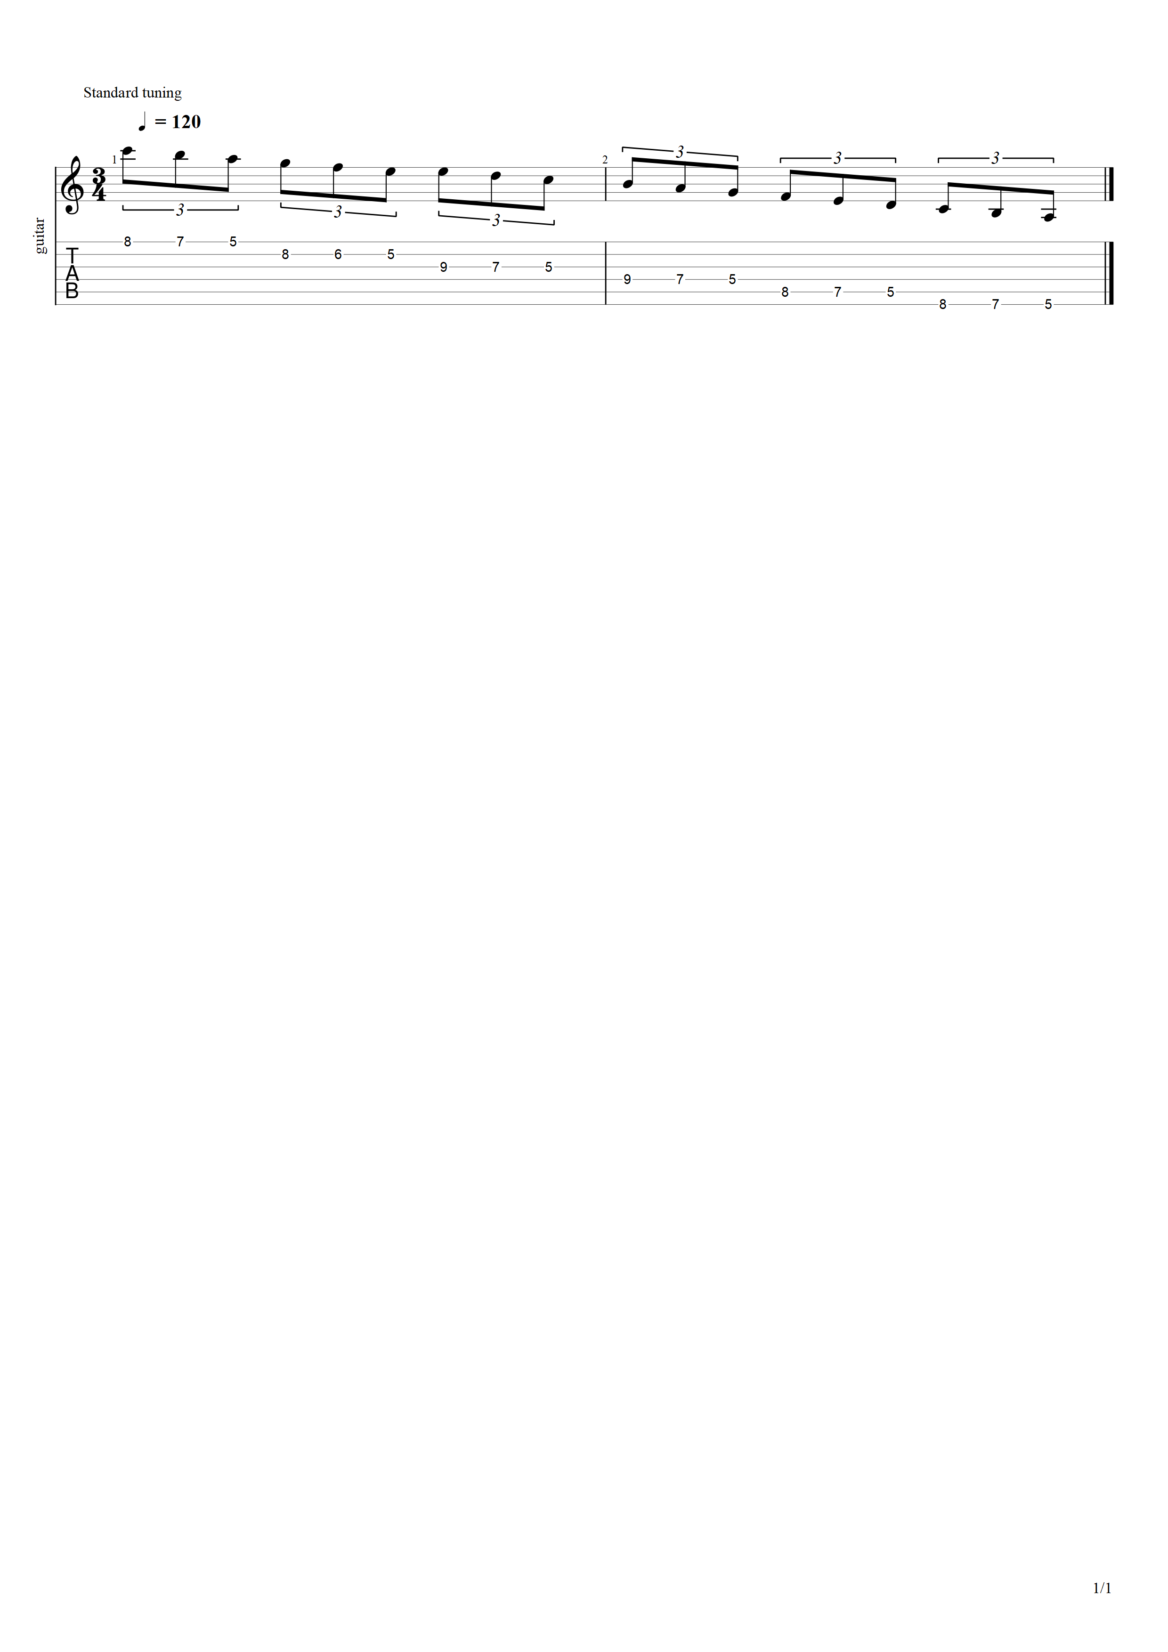

### Position 4 (Ascending)

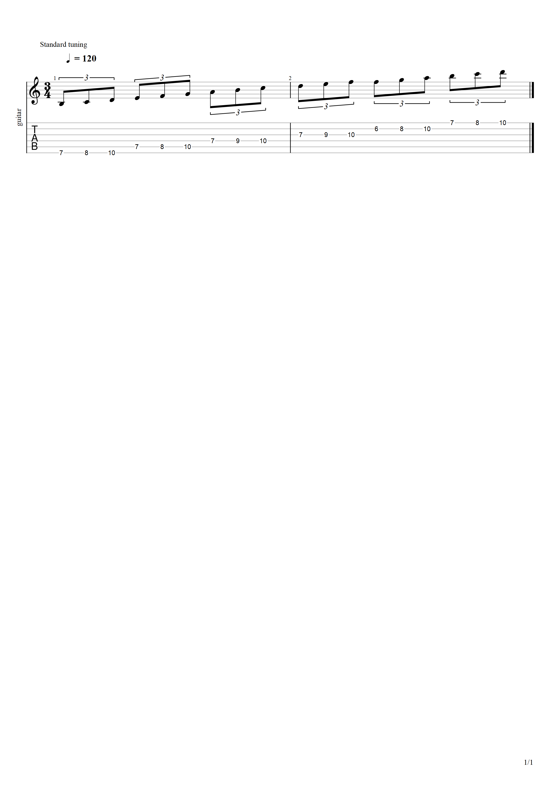

### Position 5 (Descending)

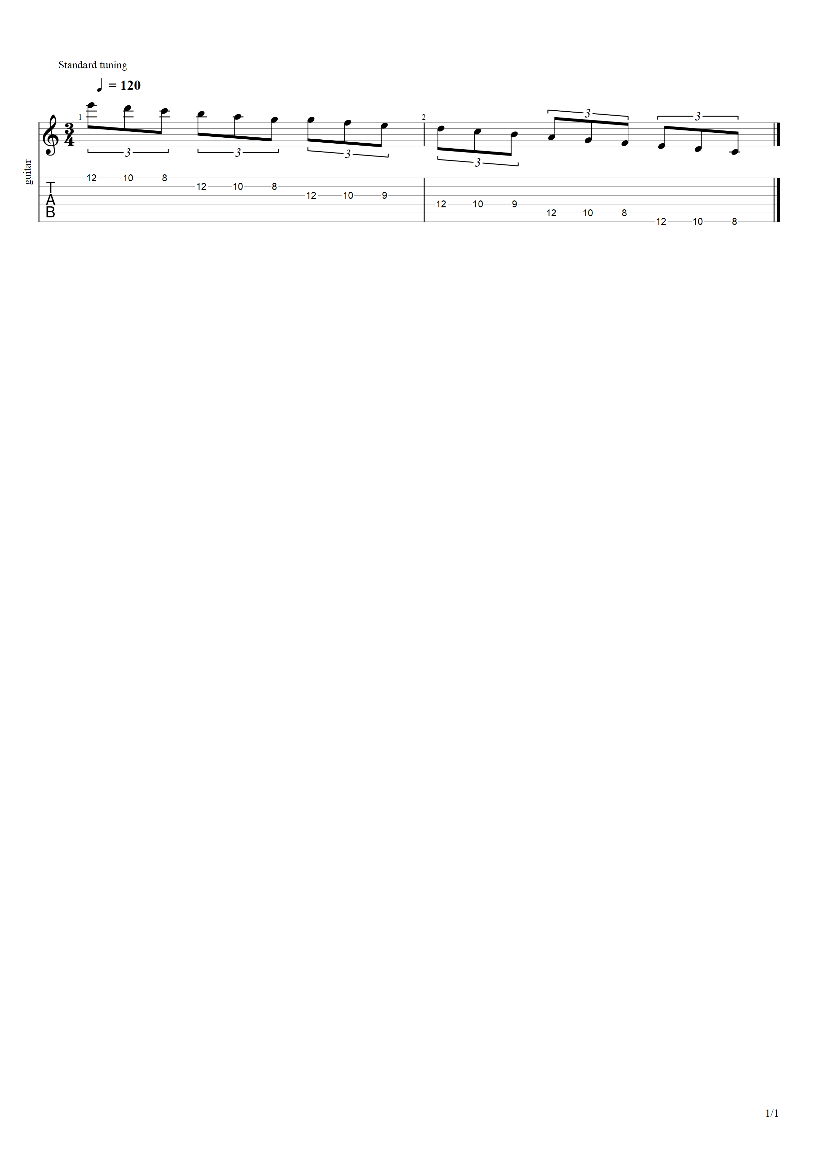

### Position 6 (Ascending)

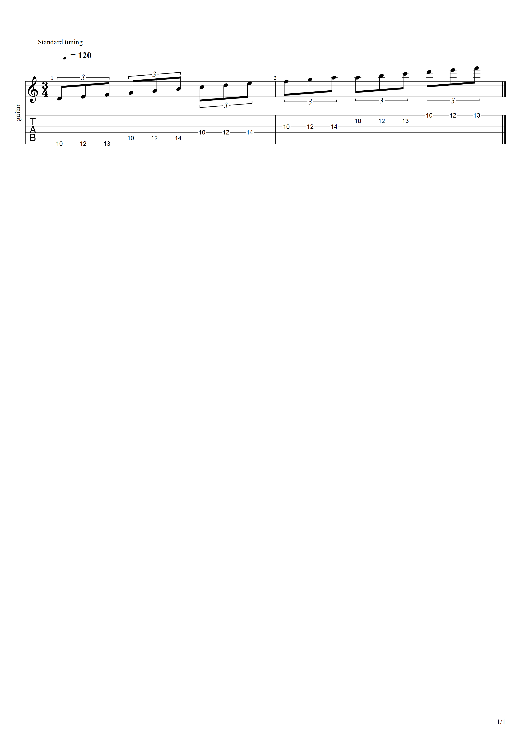

### Position 0 + 1 Octave (Descending)

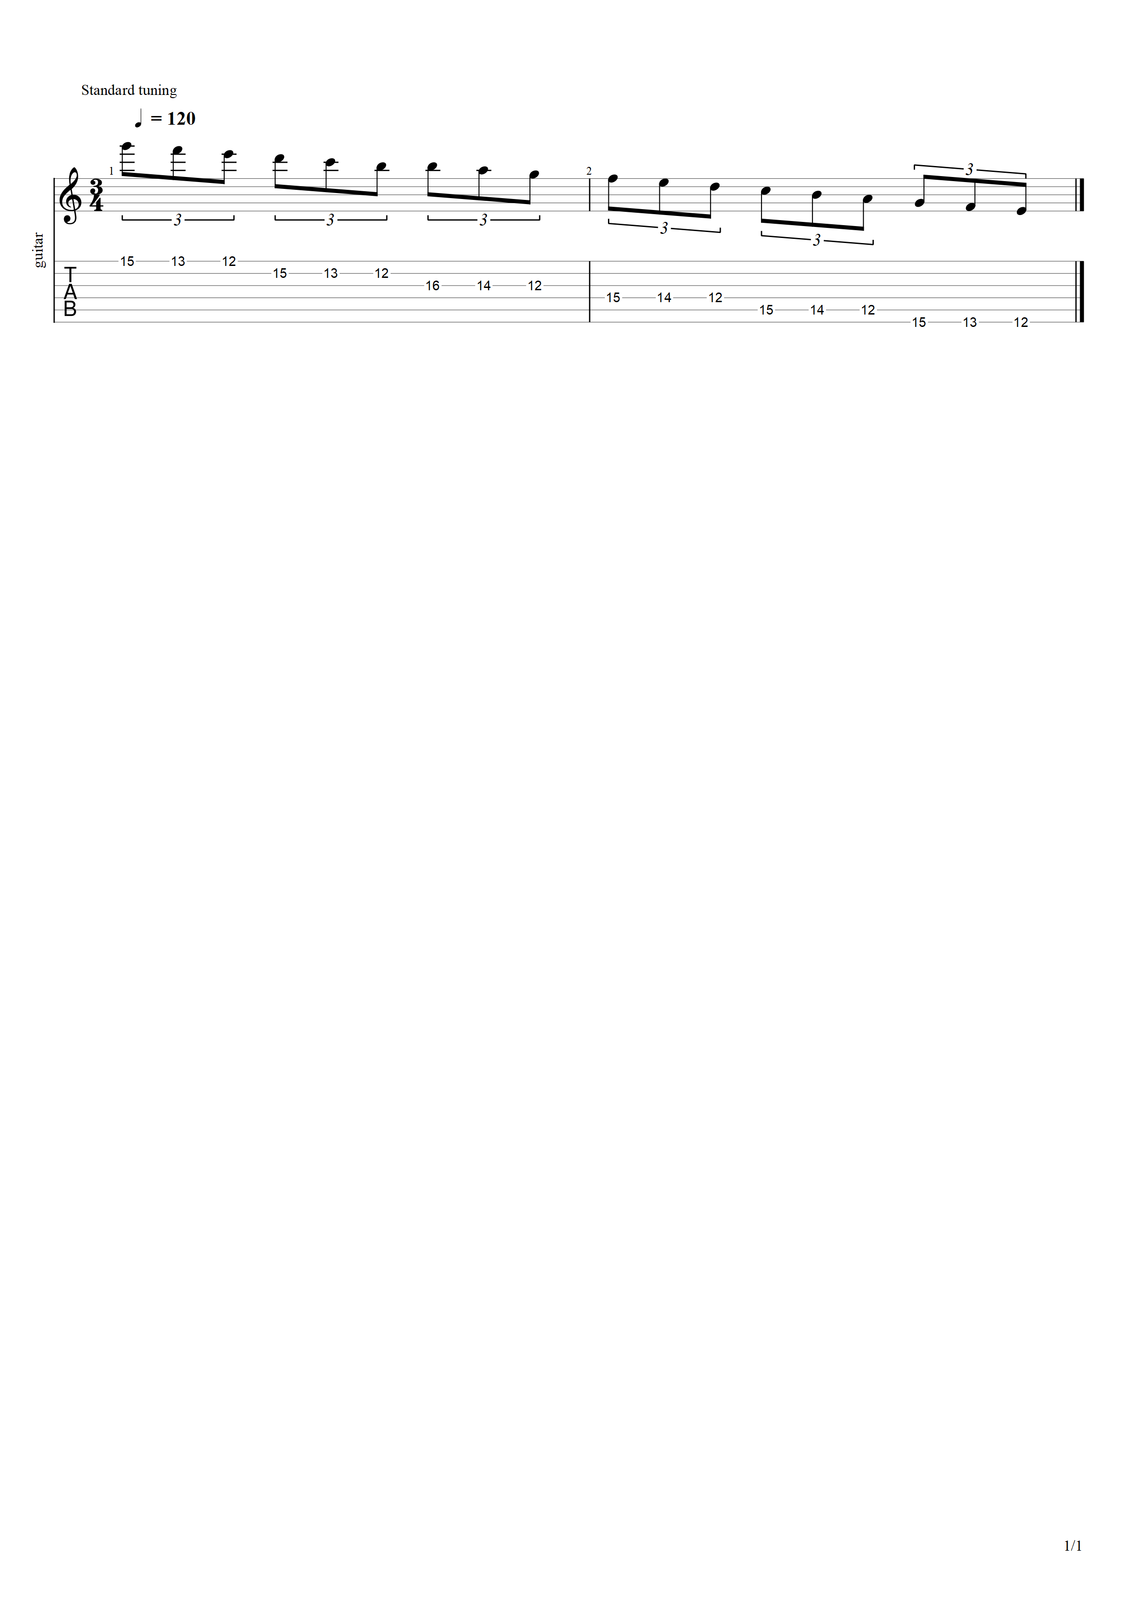

## Exercise 2: Descending/Ascending

1. Position 0 (Descending)
2. Position 1 (Ascending)
3. Position 2 (Descending)
4. Position 3 (Ascending)
5. Position 4 (Descending)
6. Position 5 (Ascending)
7. Position 6 (Descending)
8. Position 0 + 1 Octave (Ascending)

### Position 0 (Descending)

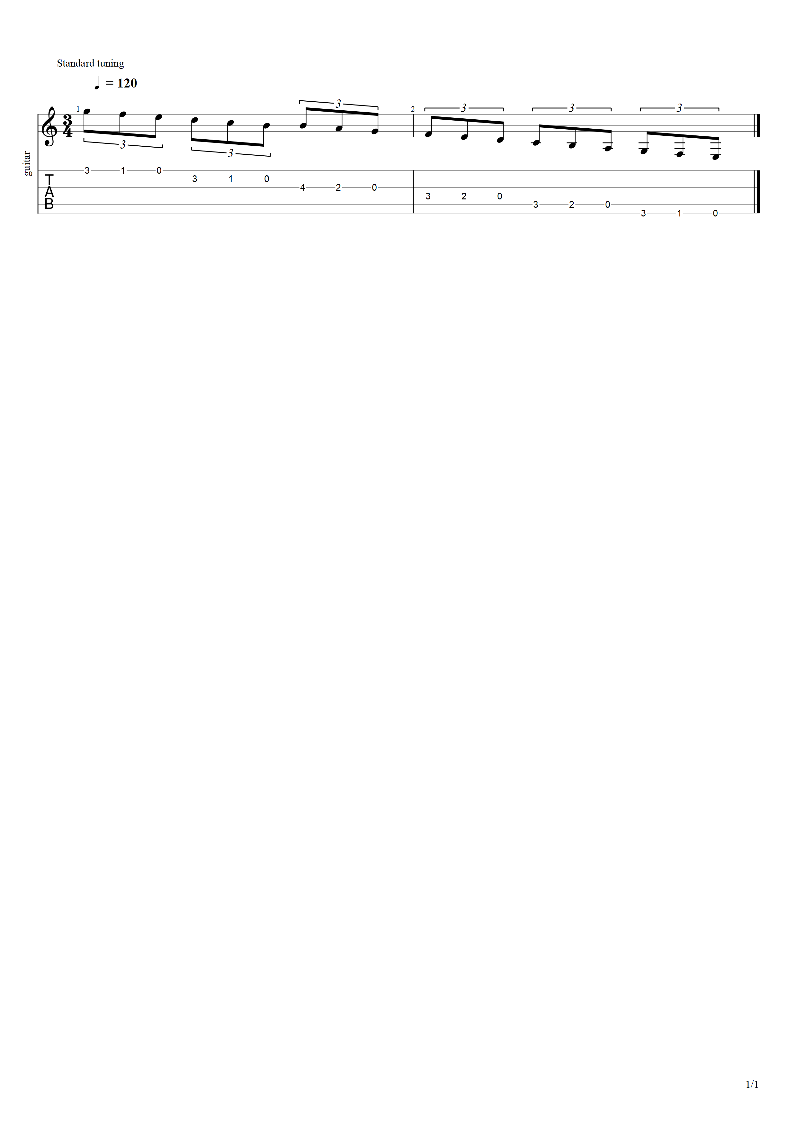

### Position 1 (Ascending)

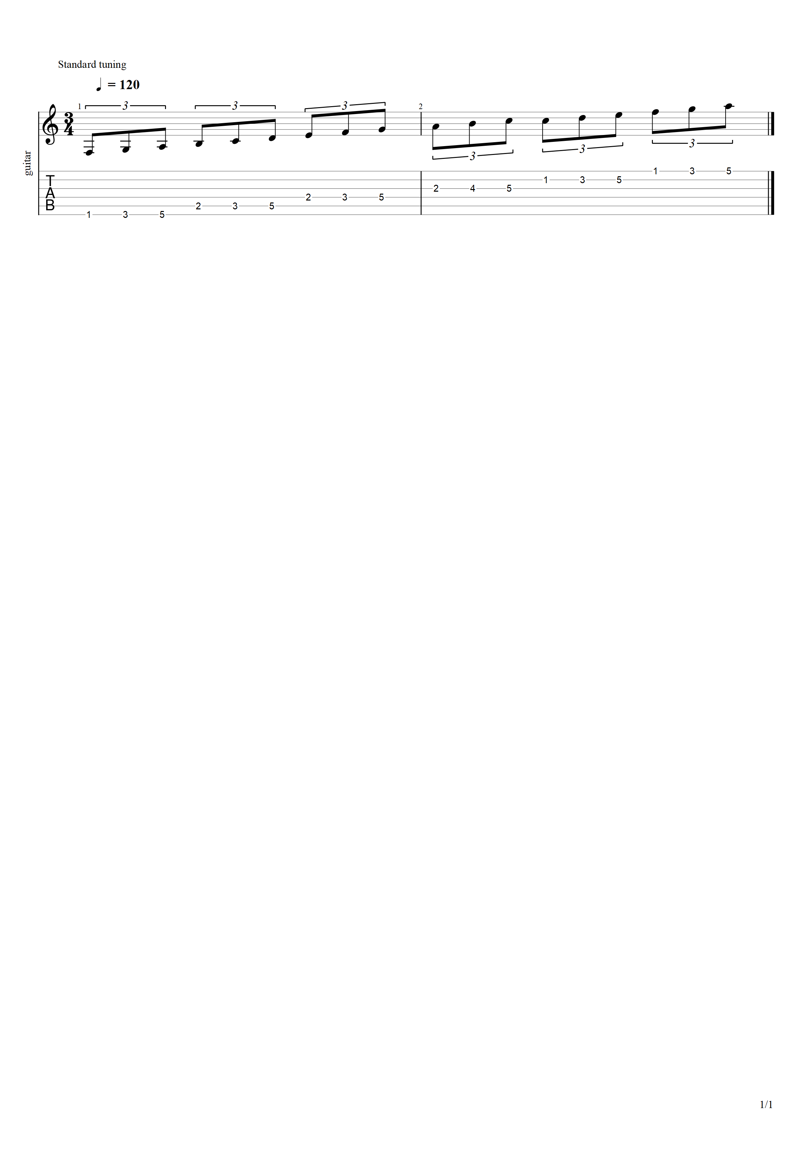

### Position 2 (Descending)

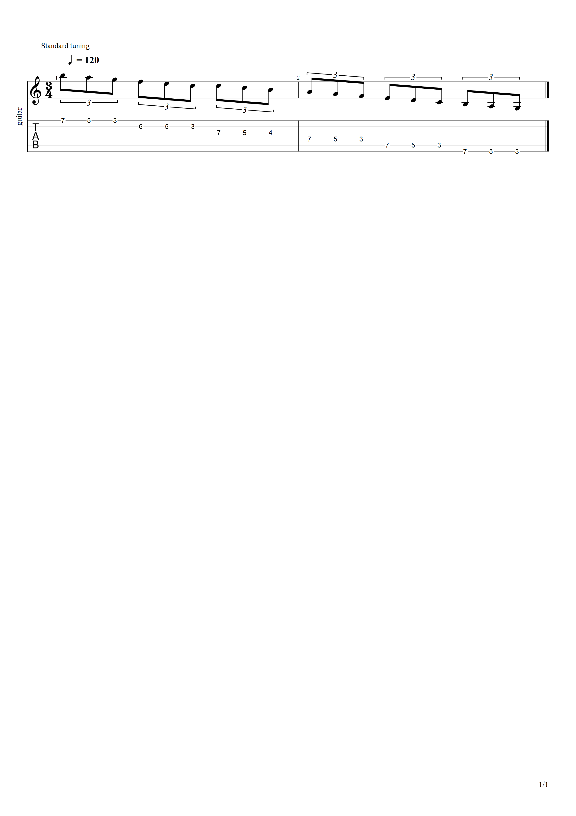

### Position 3 (Ascending)

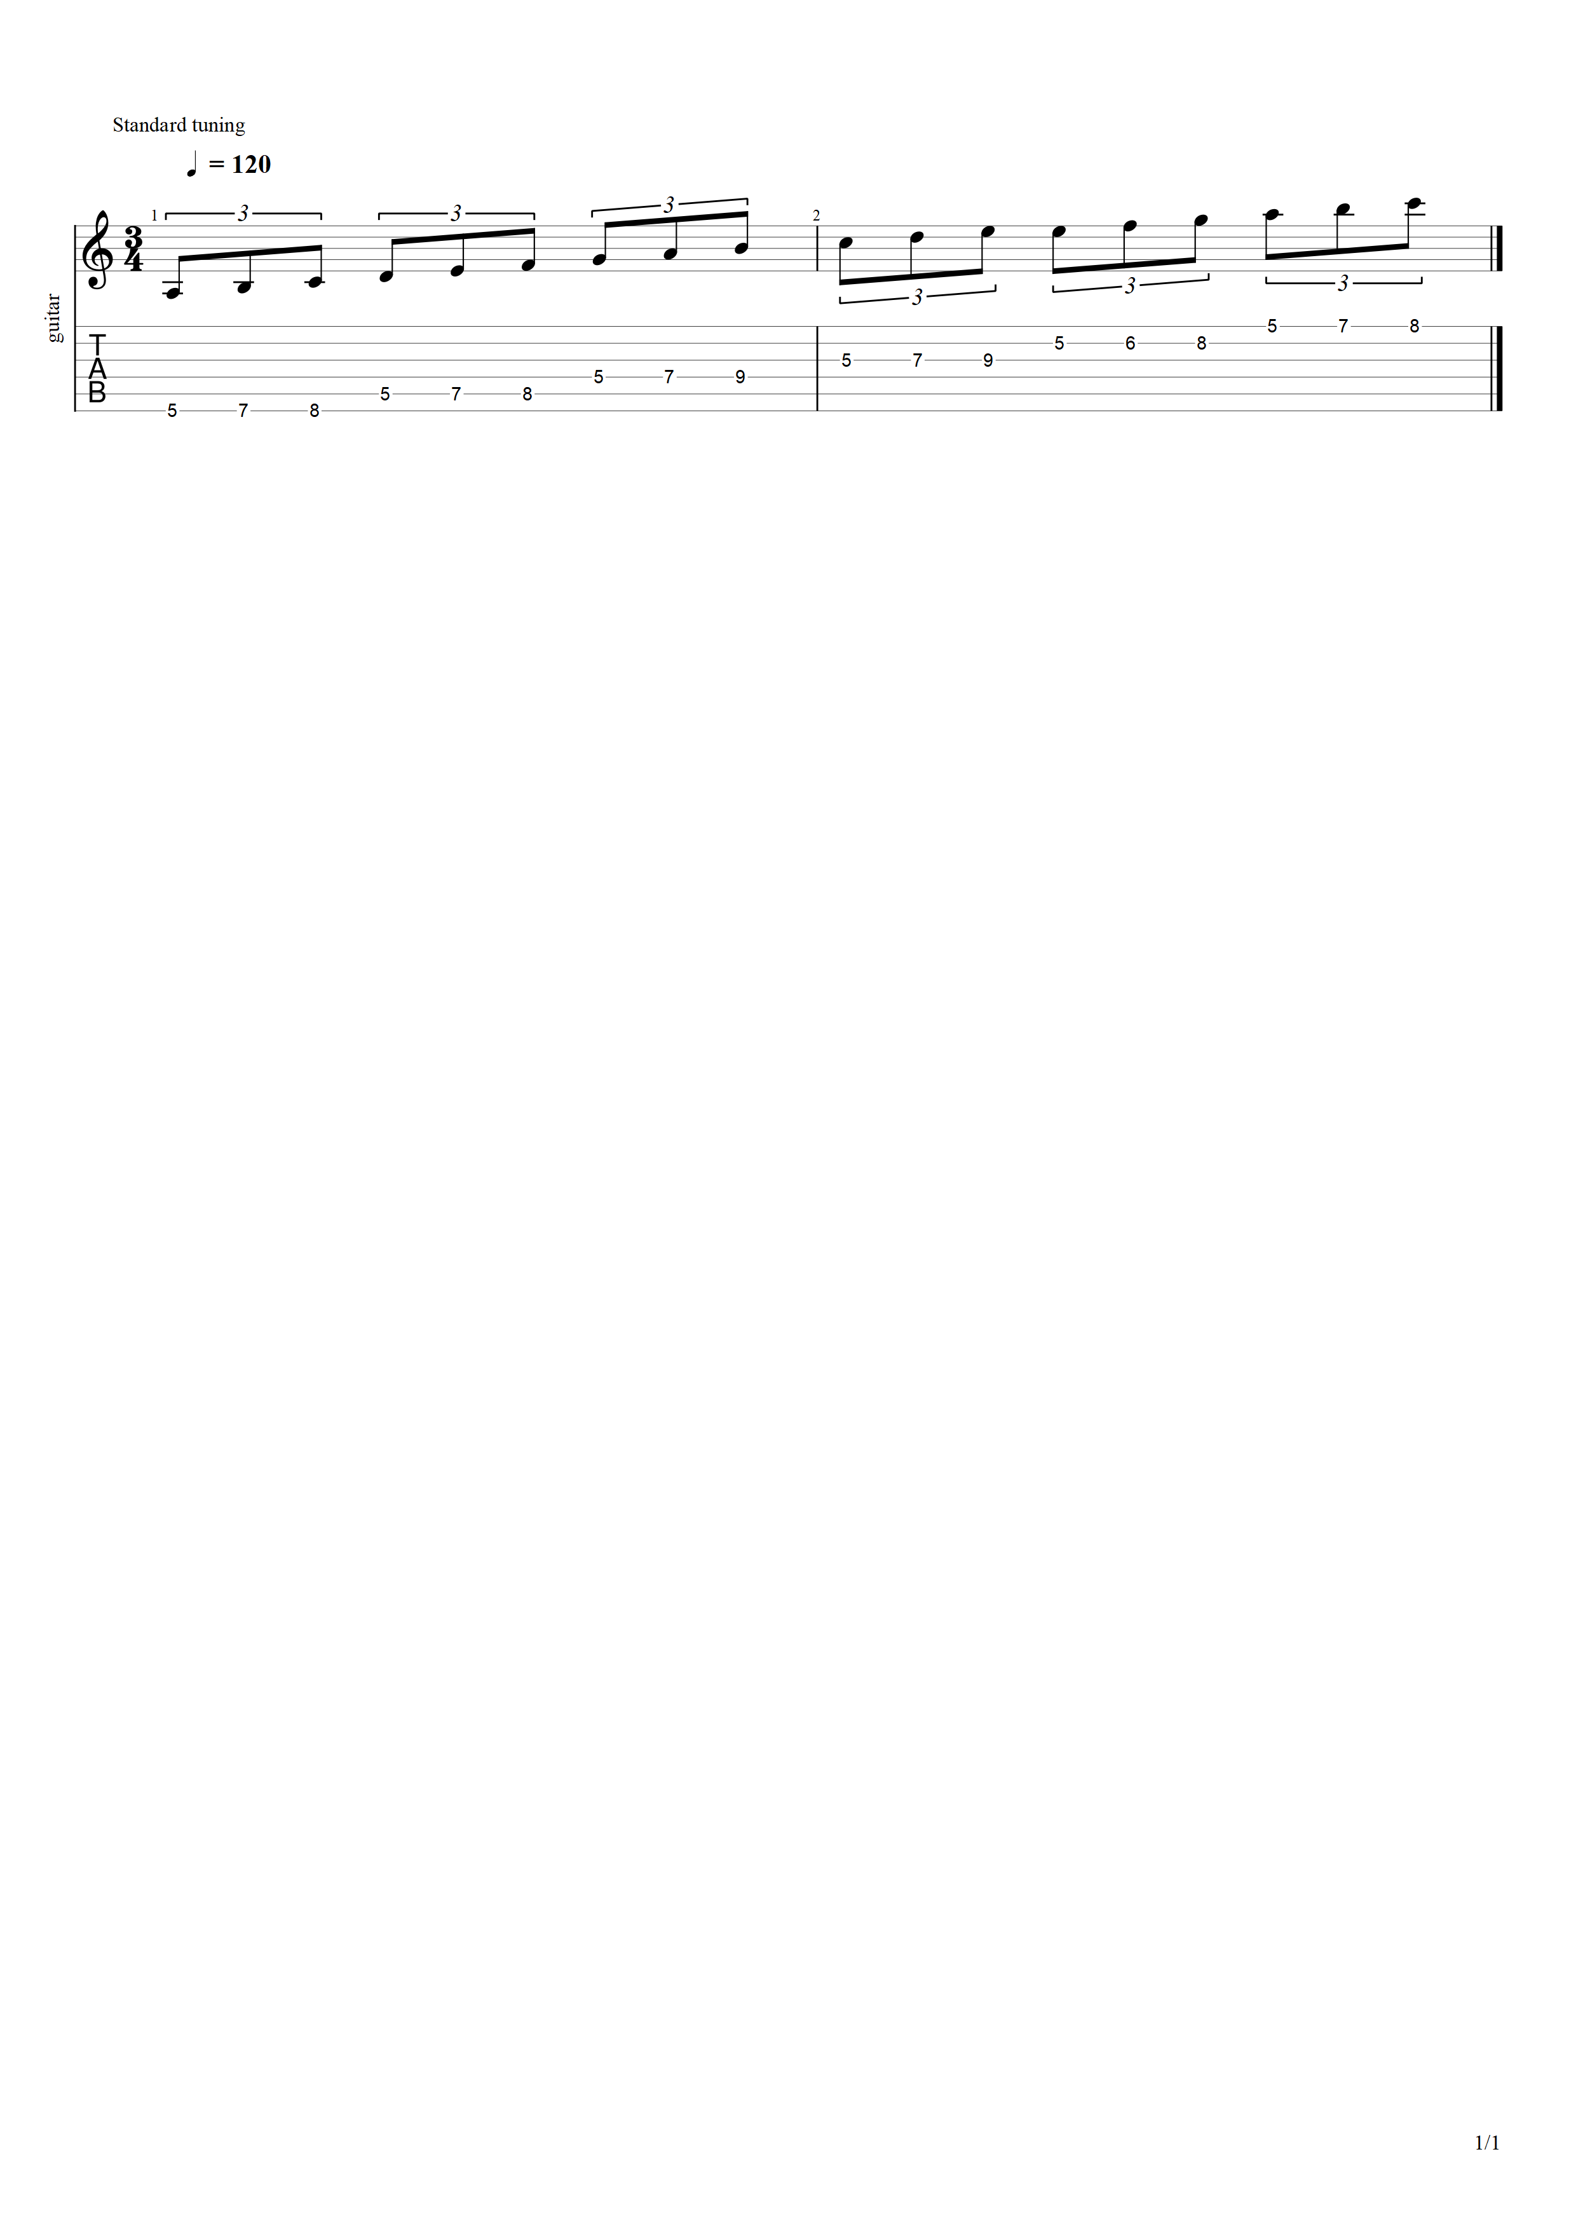

### Position 4 (Descending)

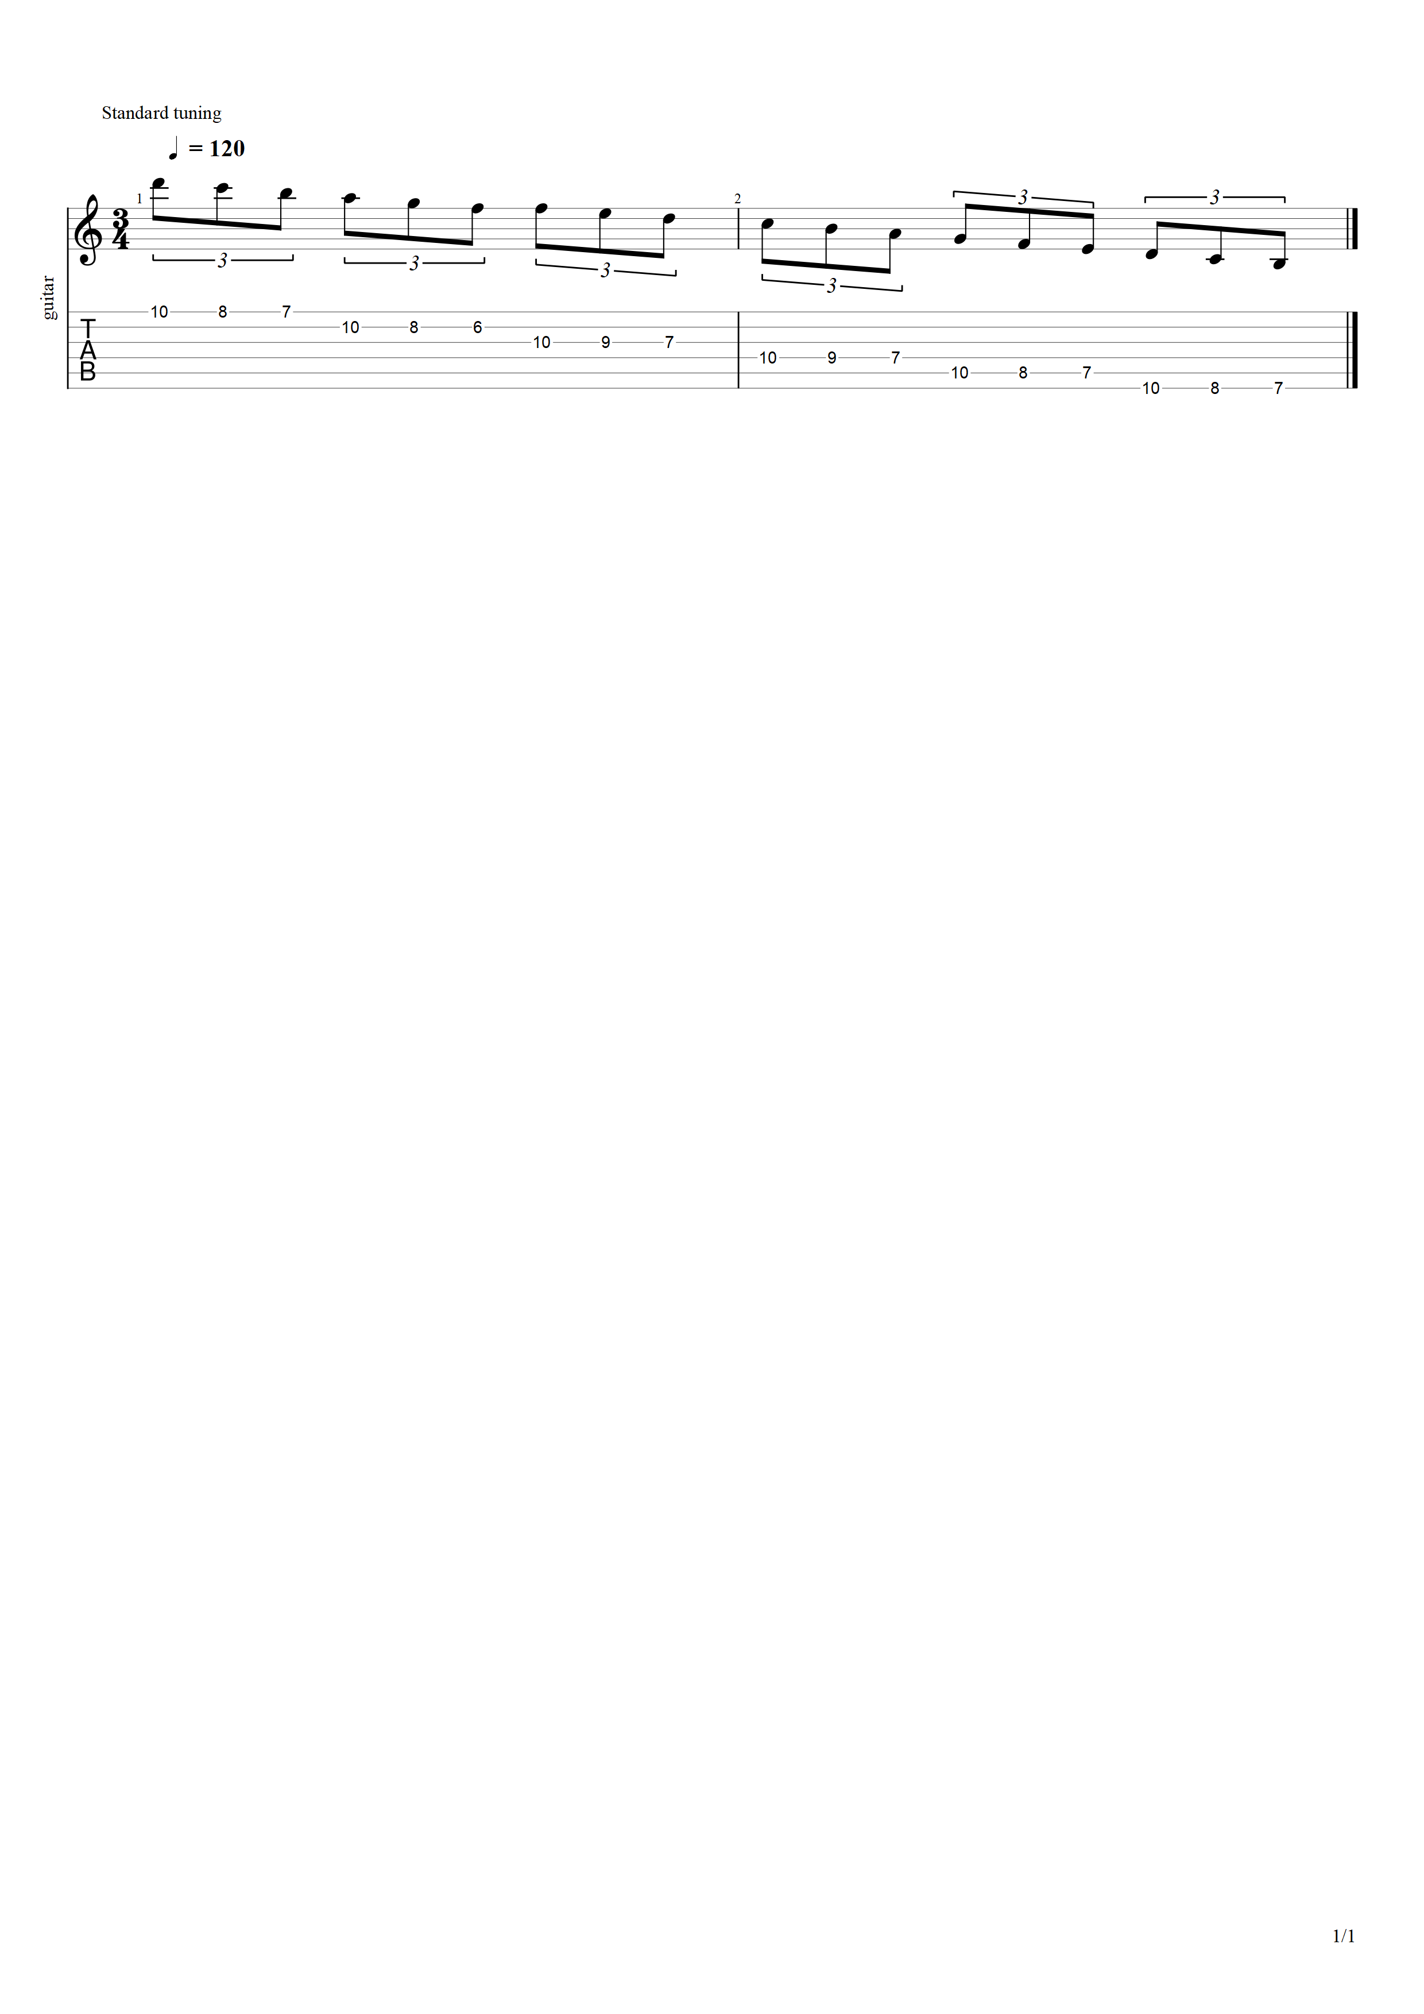

### Position 5 (Ascending)

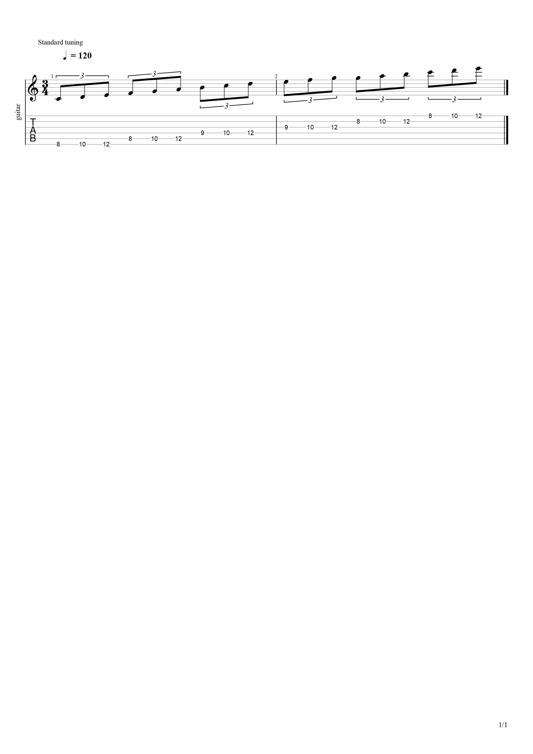

### Position 6 (Descending)

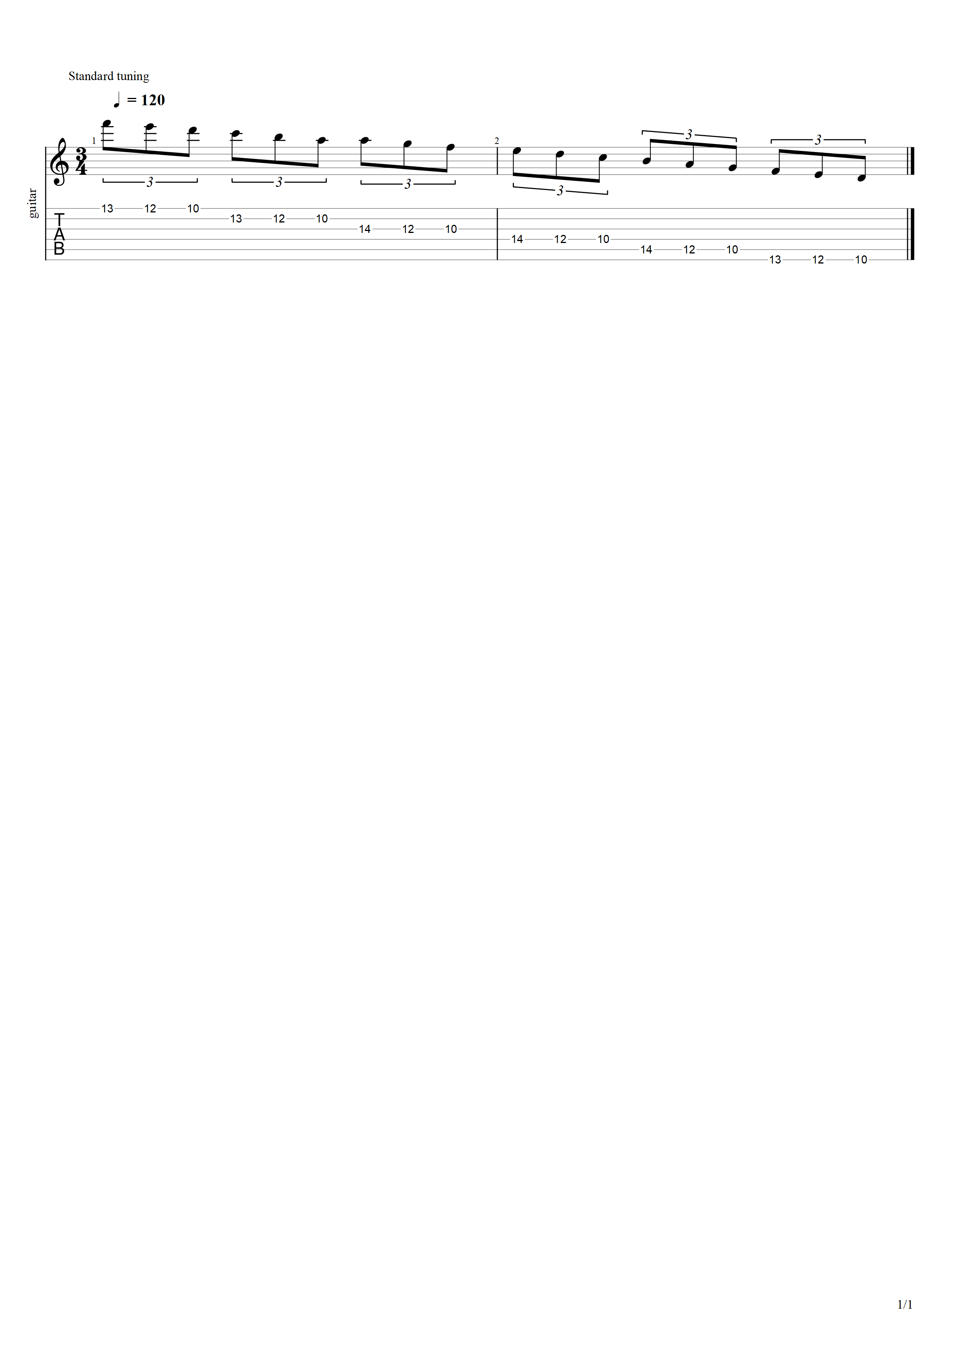

### Position 0 + 1 Octave (Ascending)

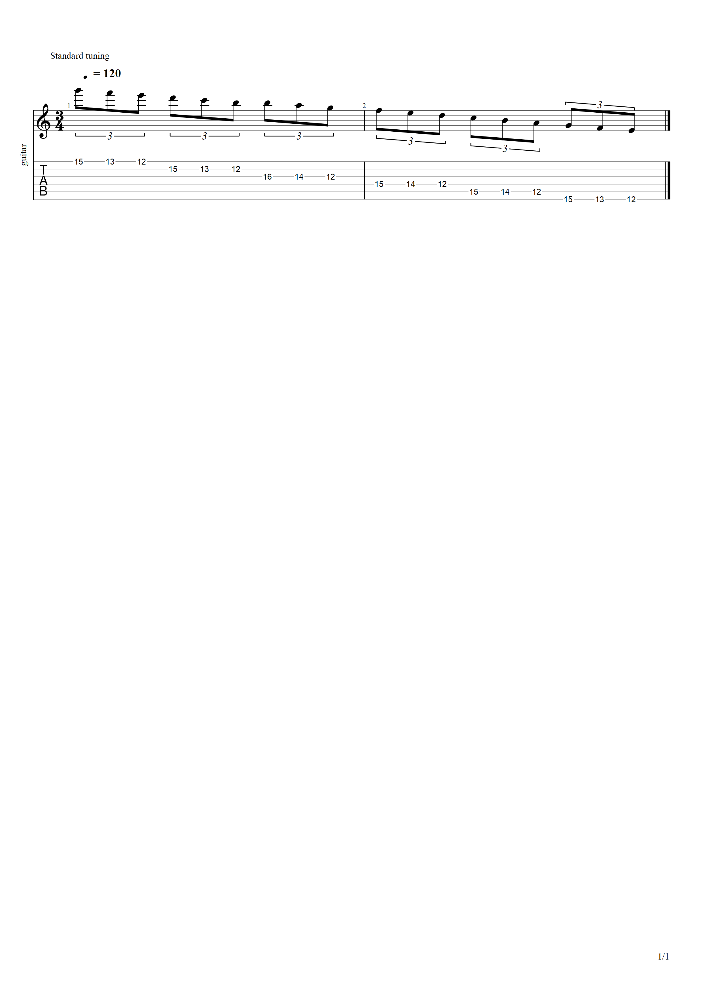

So before we move on to the next part of the lesson, I have to note that each Part will be done with all the scales before moving onto the next part. So, in this case, you’d move from **C Major/A Minor** and then to **E Major/C*#* Minor**, and so on, and so forth. Once you’ve completed all 12 scales with these two exercises, then you may move onto the next Part! The reason we do this is to warm our hands up with each of the scale positions of each scales.

# Interlude

Now that we’ve got our fingers warmed up, the next is to make your scaling a little more interesting. We’re going to be doing this by scaling in different intervals per position. We’ll start off simple with scaling in 3rd’s and then we’ll move up to 4ths, 5ths, 6th’s, and finally 7th’s. Like the following parts, this part will be divided into 8 exercises:

1. Ascending (1 - 3)/Descending (1 - 3)
2. Ascending (1 - 3)/Descending (3 - 1)
3. Ascending (3 - 1)/Descending (3 - 1)
4. Ascending (3 - 1)/Descending (1 - 3)
5. Descending (1 - 3)/Ascending (1 - 3)
6. Descending (1 - 3)/Ascending (3 - 1)
7. Descending (3 - 1)/Ascending (3 - 1)
8. Descending (3 - 1)/Ascending (1 - 3)

The way each of these work is the first part of the exercise is the direction you are moving in the scale, and the numbers in the parenthesis are the direction that the intervals move, so, for example, **Ascending (1 - 3)/Descending (3 - 1)** will start on the low-E string and work it’s way down towards the high-e string, while the ascending scale will be moving from the first to the major or minor third of said interval, and as the scale descends, the intervals will go from the major or minor third to the first interval. It’ll make more sense as you play it.

Mind you, just so you’re aware, there is a “Practice Effectively: The Complete Routine” that contains all the tabs that are shown in this document and include all of the remaining scales in the order in case you want to follow a tab. Of course, just like the remainder of this document, the remainder of this document will only present **C Major/A Minor** for its examples. If not, this document would be hundreds of pages long.

# Part 02: Scaling in Thirds

Following the scale order that was established earlier in this document, we’ll be starting on C Major/A Minor.

## Exercise 01: Ascending (1-3)/Descending (3-1)

1. Position 0 (Ascending 1 - 3)
2. Position 1 (Descending 1 - 3)
3. Position 2 (Ascending 1 - 3)
4. Position 3 (Descending 1 - 3)
5. Position 4 (Ascending 1 - 3)
6. Position 5 (Descending 1 - 3)
7. Position 7 (Ascending 1 - 3)
8. Position 0 + 1 Octave (Descending 1 - 3)

### Position 0 (Ascending 1 - 3)

### Position 1 (Descending 1 - 3)

### Position 2 (Ascending 1 - 3)

### Position 3 (Descending 1 - 3)

### Position 4 (Ascending 1 - 3)

### Position 5 (Descending 1 - 3)

### Position 7 (Ascending 1 - 3)

### Position 0 + 1 Octave (Descending 1 - 3)